Project 01 - 1 Hour

Deploying a Scalable Web Application with Persistent Storage and Advanced Automation

Objective:
Deploy a scalable web application using Docker Swarm and Kubernetes, ensuring data persistence using a single shared volume, and automate the process using advanced shell scripting.

Overview:
- Step 1: Set up Docker Swarm and create a service.
- Step 2: Set up Kubernetes using Minikube.
- Step 3: Deploy a web application using Docker Compose.
- Step 4: Use a single shared volume across multiple containers.
- Step 5: Automate the entire process using advanced shell scripting.

Step 1: Set up Docker Swarm and Create a Service

1.1 Initialize Docker Swarm

# Initialize Docker Swarm
docker swarm init
this command showing error for IP address so user ` docker swarm --advertise-addr 192.168.56.13 `
this command initialize swarm

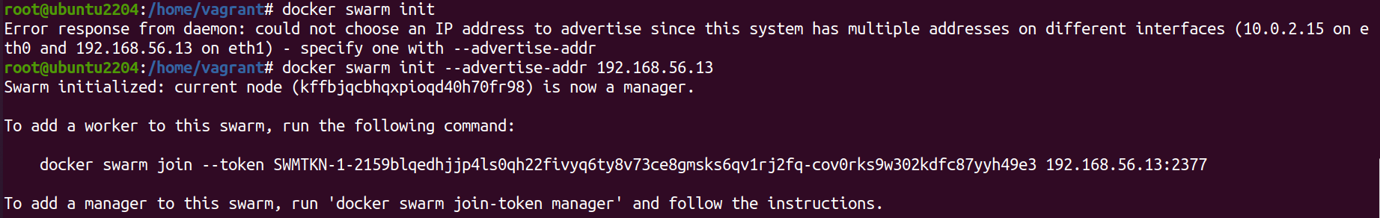

1.2 Create a Docker Swarm Service

# Create a simple Nginx service in Docker Swarm
docker service create --name nginx-service --publish 8080:80 nginx

to use this comand first we need nginx image
so use command ` docker pull nginx ` to pull nginx image
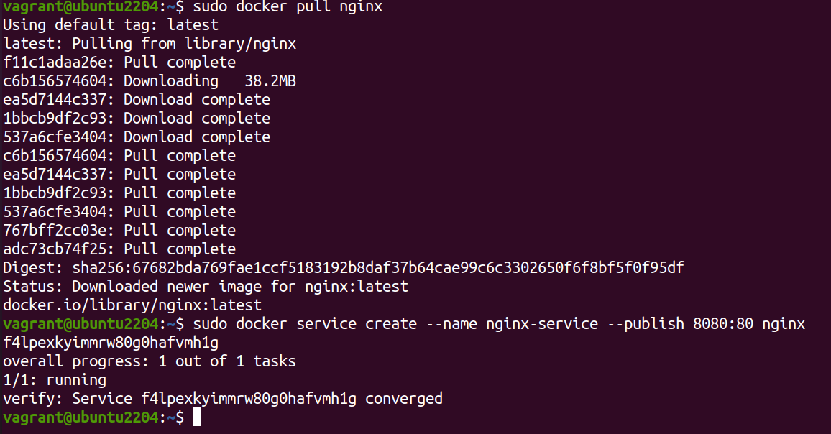

Step 2: Set up Kubernetes Using Minikube

2.1 first downloaded the Minikube using command :
curl -LOhttps://storage.googleapis.com/minikube/releases/latest/minikube-linux-amd64
sudo install minikube-linux-amd64 /usr/local/bin/minikube && rm minikube-linux-amd64

2.2 Start Minikube

# Start Minikube
minikube start
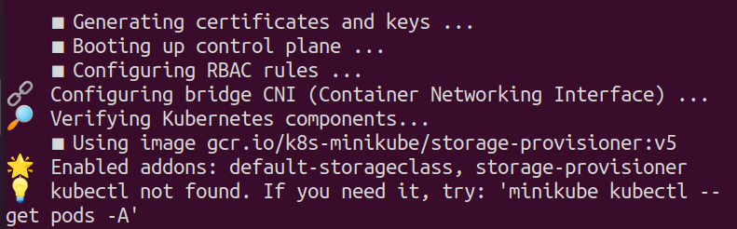
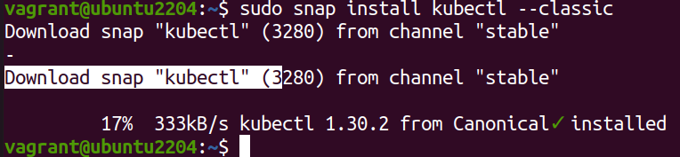

2.3 Deploy a Web App on Kubernetes
Create a deployment file named webapp-deployment.yaml:

apiVersion: apps/v1
kind: Deployment
metadata:
name: webapp
spec:
replicas: 3
selector:
matchLabels:
app: webapp
template:
metadata:
labels:
app: webapp
spec:
containers:
- name: webapp
image: nginx
ports:
- containerPort: 80

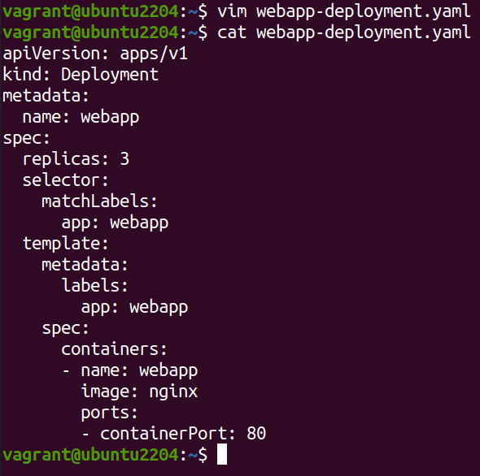
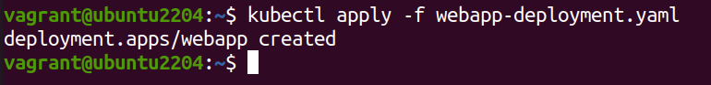
Apply the deployment:
kubectl apply -f webapp-deployment.yaml

2.4 Expose the Deployment
kubectl expose deployment webapp --type=NodePort --port=80

Step 3: Deploy a Web Application Using Docker Compose

3.1 Create a docker-compose.yml File

version: '3'
services:
web:
image: nginx
ports:
- "8080:80"
volumes:
- webdata:/usr/share/nginx/html

volumes:
webdata:
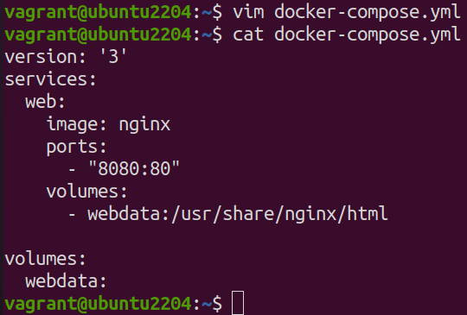

3.2 Deploy the Web Application

# Deploy using Docker Compose
docker-compose up -d
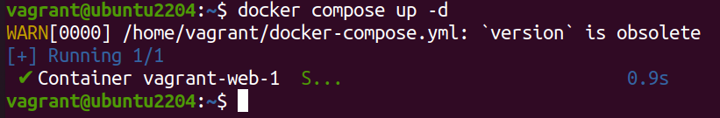

Step 4: Use a Single Shared Volume Across Multiple Containers

4.1 Update docker-compose.yml to Use a Shared Volume

version: '3'
services:
web1:
image: nginx
ports:
- "8081:80"
volumes:
- shareddata:/usr/share/nginx/html
web2:
image: nginx
ports:
- "8082:80"
volumes:
- shareddata:/usr/share/nginx/html

volumes:
shareddata:
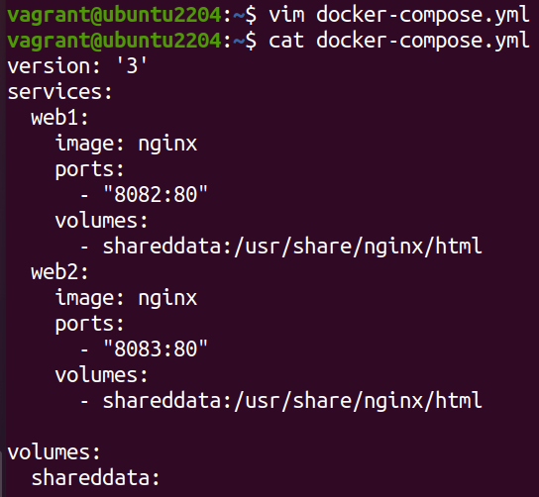

4.2 Deploy with Docker Compose

# Deploy using Docker Compose
docker-compose up -d
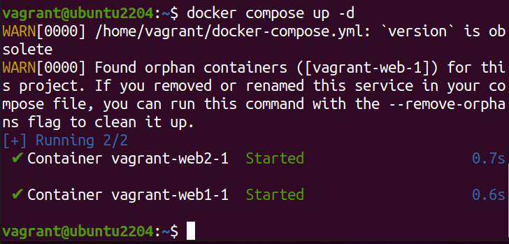

Step 5: Automate the Entire Process Using Advanced Shell Scripting

5.1 Create a Shell Script deploy.sh

#!/bin/bash

# Initialize Docker Swarm
docker swarm init

# Create Docker Swarm Service
docker service create --name nginx-service --publish 8080:80 nginx

# Start Minikube
minikube start

# Create Kubernetes Deployment
kubectl apply -f webapp-deployment.yaml

# Expose the Deployment
kubectl expose deployment webapp --type=NodePort --port=80

# Deploy Web App Using Docker Compose
docker-compose -f docker-compose-single-volume.yml up -d

echo "Deployment completed successfully!"
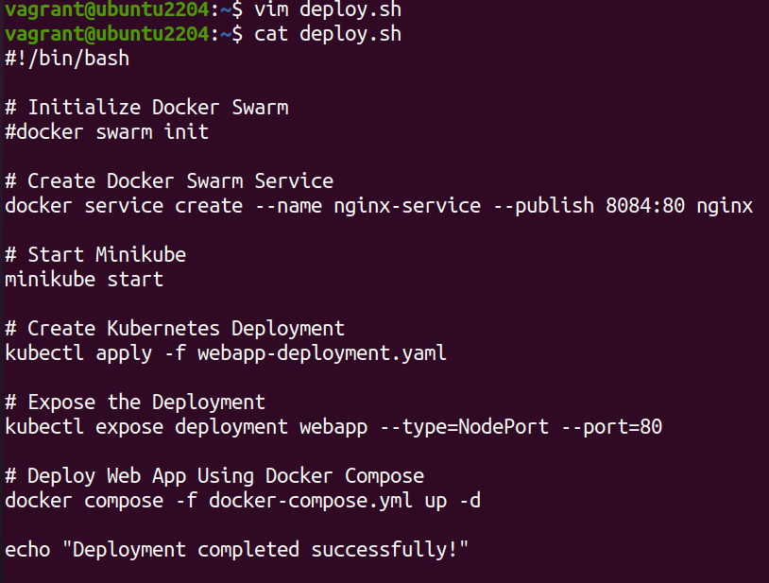

5.2 Make the Script Executable

# Make the script executable
chmod +x deploy.sh

5.3 Run the Script

# Run the deployment script
./deploy.sh
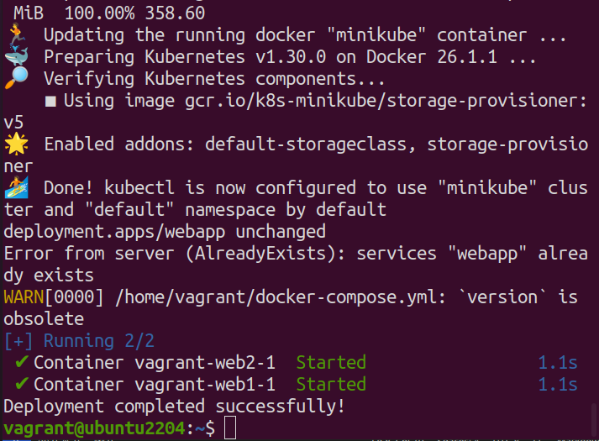

Project 02 - 1 Hour

Comprehensive Deployment of a Multi-Tier Application with CI/CD Pipeline

Objective:
Deploy a multi-tier application (frontend, backend, and database) using Docker Swarm and Kubernetes, ensuring data persistence using a single shared volume across multiple containers, and automating the entire process using advanced shell scripting and CI/CD pipelines.

Overview:
- Step 1: Set up Docker Swarm and create a multi-tier service.
- Step 2: Set up Kubernetes using Minikube.
- Step 3: Deploy a multi-tier application using Docker Compose.
- Step 4: Use a single shared volume across multiple containers.
- Step 5: Automate the deployment process using advanced shell scripting.

Step 1: Set up Docker Swarm and Create a Multi-Tier Service

1.1 Initialize Docker Swarm

# Initialize Docker Swarm
docker swarm init

1.2 Create a Multi-Tier Docker Swarm Service
Create a docker-compose-swarm.yml file:
version: '3.7'
services:
frontend:
image: nginx
ports:
- "8080:80"
deploy:
replicas: 2
volumes:
- shareddata:/usr/share/nginx/html
backend:
image: mybackendimage
ports:
- "8081:80"
deploy:
replicas: 2
volumes:
- shareddata:/app/data
db:
image: postgres
environment:
POSTGRES_DB: mydb
POSTGRES_USER: user
POSTGRES_PASSWORD: password
deploy:
replicas: 1
volumes:
- dbdata:/var/lib/postgresql/data

volumes:
shareddata:
dbdata:

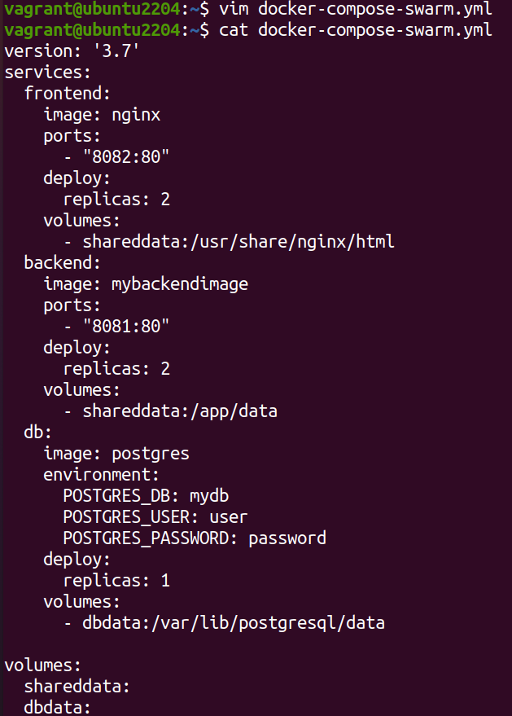

Deploy the stack:
# Deploy the stack using Docker Swarm
docker stack deploy -c docker-compose-swarm.yml myapp
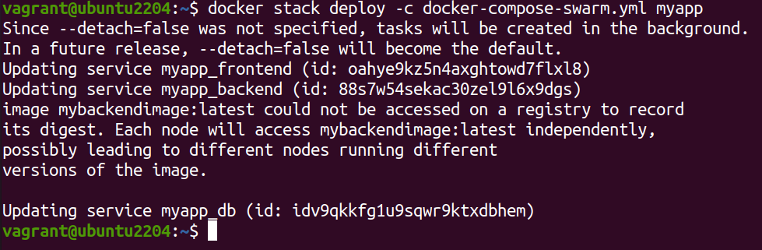

Step 2: Set up Kubernetes Using Minikube

2.1 Start Minikube

# Start Minikube
minikube start

2.2 Create Kubernetes Deployment Files
Create frontend-deployment.yaml:

apiVersion: apps/v1
kind: Deployment
metadata:
name: frontend
spec:
replicas: 2
selector:
matchLabels:
app: frontend
template:
metadata:
labels:
app: frontend
spec:
containers:
- name: frontend
image: nginx
ports:
- containerPort: 80
volumeMounts:
- name: shareddata
mountPath: /usr/share/nginx/html
volumes:
- name: shareddata
persistentVolumeClaim:
claimName: shared-pvc
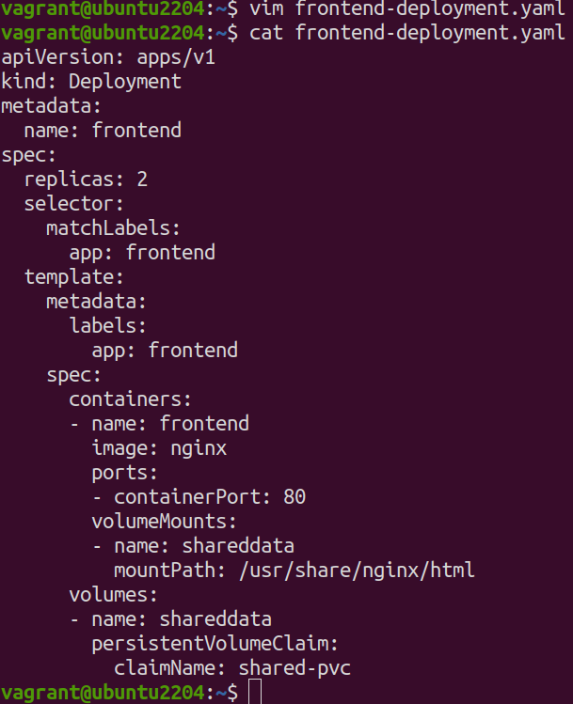
Create backend-deployment.yaml:
apiVersion: apps/v1
kind: Deployment
metadata:
name: backend
spec:
replicas: 2
selector:
matchLabels:
app: backend
template:
metadata:
labels:
app: backend
spec:
containers:
- name: backend
image: mybackendimage
ports:
- containerPort: 80
volumeMounts:
- name: shareddata
mountPath: /app/data
volumes:
- name: shareddata
persistentVolumeClaim:
claimName: shared-pvc

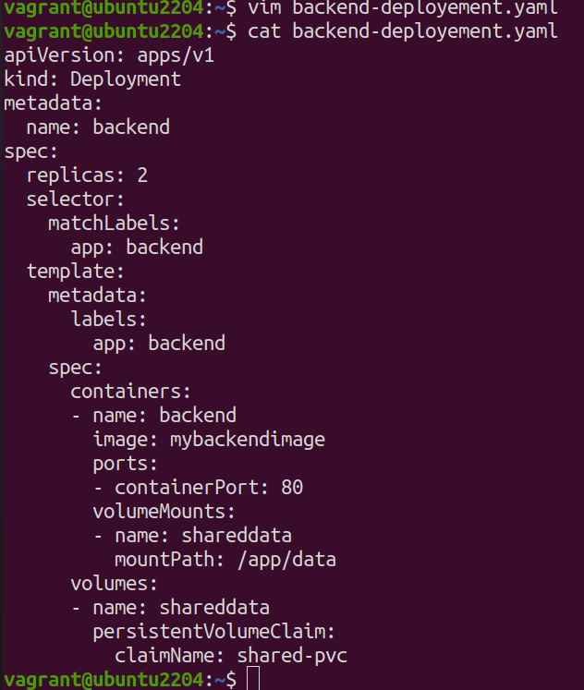

Create db-deployment.yaml:
apiVersion: apps/v1
kind: Deployment
metadata:
name: db
spec:
replicas: 1
selector:
matchLabels:
app: db
template:
metadata:
labels:
app: db
spec:
containers:
- name: db
image: postgres
env:
- name: POSTGRES_DB
value: mydb
- name: POSTGRES_USER
value: user
- name: POSTGRES_PASSWORD
value: password
volumeMounts:
- name: dbdata
mountPath: /var/lib/postgresql/data
volumes:
- name: dbdata
persistentVolumeClaim:
claimName: db-pvc

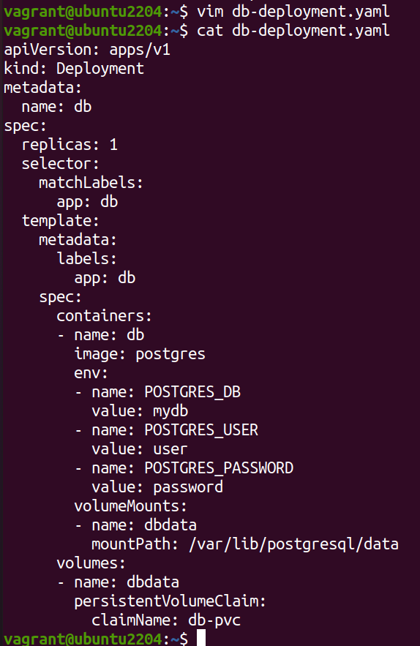

Create shared-pvc.yaml:
apiVersion: v1
kind: PersistentVolumeClaim
metadata:
name: shared-pvc
spec:
accessModes:
- ReadWriteMany
resources:
requests:
storage: 1Gi
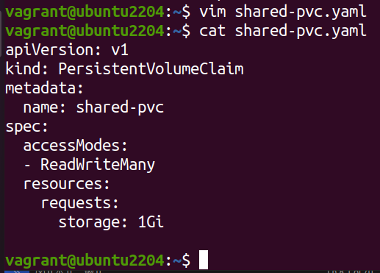

Create db-pvc.yaml:
apiVersion: v1
kind: PersistentVolumeClaim
metadata:
name: db-pvc
spec:
accessModes:
- ReadWriteOnce
resources:
requests:
storage: 1Gi

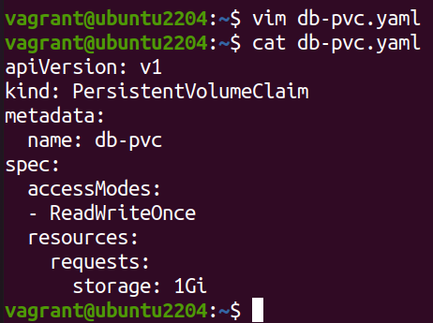

Apply the deployments:
kubectl apply -f shared-pvc.yaml
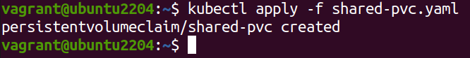

kubectl apply -f db-pvc.yaml
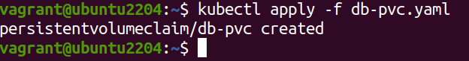

kubectl apply -f frontend-deployment.yaml
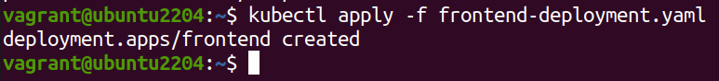
kubectl apply -f backend-deployment.yaml
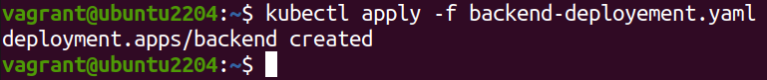

kubectl apply -f db-deployment.yaml
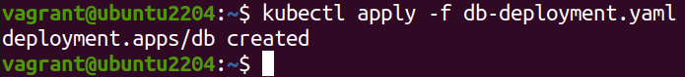

Step 3: Deploy a Multi-Tier Application Using Docker Compose

3.1 Create a docker-compose.yml File

version: '3'
services:
frontend:
image: nginx
ports:
- "8080:80"
volumes:
- shareddata:/usr/share/nginx/html
backend:
image: mybackendimage
ports:
- "8081:80"
volumes:
- shareddata:/app/data
db:
image: postgres
environment:
POSTGRES_DB: mydb
POSTGRES_USER: user
POSTGRES_PASSWORD: password
volumes:
- dbdata:/var/lib/postgresql/data

volumes:
shareddata:
dbdata:

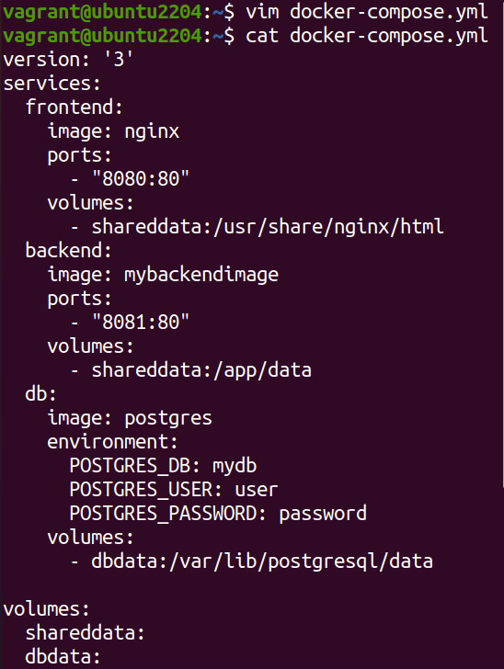

3.2 Deploy the Application

# Deploy using Docker Compose
docker-compose up -d

Step 4: Use a Single Shared Volume Across Multiple Containers
Update docker-compose.yml as shown in Step 3.1 to use the shareddata volume across the frontend and backend services.

